**Game Project**

**By: Trần Cẩm Vinh**

The project I will represent is call Dragon Tale, this is the game talk about the adventure of the dragon.

To begin with, I have create some packages: audio for the sound effects in the game, entity for the dragon animation and monsters, the game state, tilemap for background and map, and the main to run the game

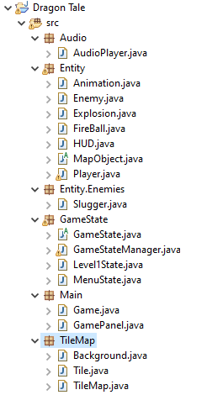

I search on the Internet for the background, dragon and monsters. Here are some pictures of it:

1. **Background**

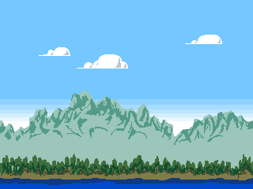



1. **Character**

Dragon:

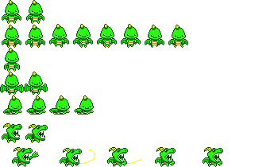

Enemies:



1. **Effects**



This is the 2D game, we can easily move left and right the dragon with arrow keys, w to jump and e to fly, we can press f to create and fireball. Here is the link to gifhub: <https://github.com/trancamvinh2001/game>. This link will implement about the map, audio, characters movement and more,…

Through this project, I have realized many things about my industry to help me understand more about my future work. Because I am still in the process of studying, it is difficult to avoid mistakes, I hope you consider and correct me to help me improve.